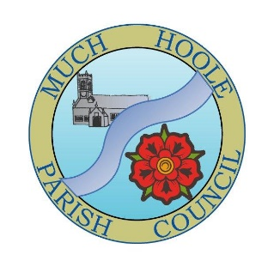 | MUCH HOOLE PARISH COUNCIL  NOTICE OF MEETING: Extraordinary Meeting Agenda
 | You are hereby summoned to attend an Extraordinary Meeting of Much Hoole Parish Council at 7.00pm on Monday 24th June 2024. The meeting will be held at The Venue at Hoole Village Memorial Hall, Liverpool Old Road, PR4 5QA.
AGENDA
1. | Apologies for Absence: To receive apologies. Cllr N Woodcock
2. | Declaration of Interests and Dispensations  To declare any personal or pecuniary interest in respect of matters contained in this agenda or brought up at any point in this meeting.
3. | AGAR Annual Audit  - Presentation of the Annual Governance and Accountability Return (AGAR): Clerk to present the completed AGAR forms.  - Review and Approval of the Annual Governance Statement: Council to approve each assertion in the Annual Governance Statement.  - Review and Approval of the Accounting Statements: Council to approve the accounting statements prepared by the responsible RFO.  - Internal Auditors Report: Discussion on the internal auditor’s findings and recommendations.  - Public Rights Notice: Public Rights Notice – confirm the dates for the period of public rights to inspect the AGAR documents.  - Submission and Publication: Council to agree the submission of the approved AGAR to the external auditor and publication on the MHPC website.
5. | Public Time: To invite and listen to issues raised by members of the public regarding the AGAR
22. | Close of Meeting

